WEEK - 8
Yash Raj
SuperSet ID - (6364442)

Git-HOL
Installing Git
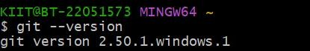
Configuring the username and user-email
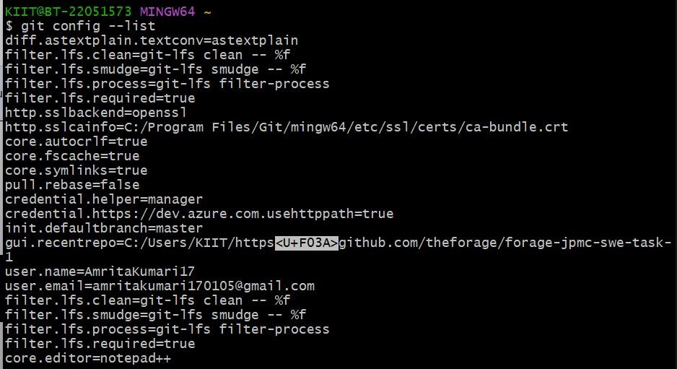
Navigating to the local repo
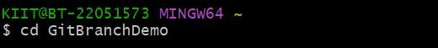

  - Verify if master is in clean state.
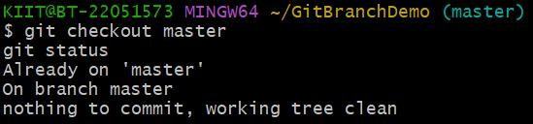
  - List out all the available branches.
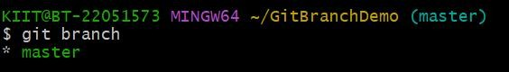

  - Pull the remote git repository to the master
  - Push the changes, which are pending from “Git-T03-HOL_002” to the remote repository.
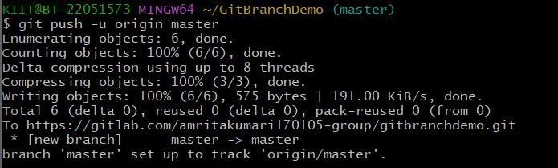
  - Observe if the changes are reflected in the remote repository.
